**ETL Project - LA Restaurant and Market Health**

**Datasets**

Restaurant and Market Health violations and Inspection - From: Kaggle

**Objectives**

* **E:** Reading csv files for inspections and violations. Scrapped Yelp for restaurant rating.
* **T:** Iterate inspections and insert violations into inspection
* **L:** Store data in Json form to load into Mongo DB

**Summary**

The input datasets, inspections data and violations data, were read in as csv formats. These datasets were converted to DataFrames using pandas.

From the above datasets, generated an inspection summary with violations data corresponding to every inspection serial number

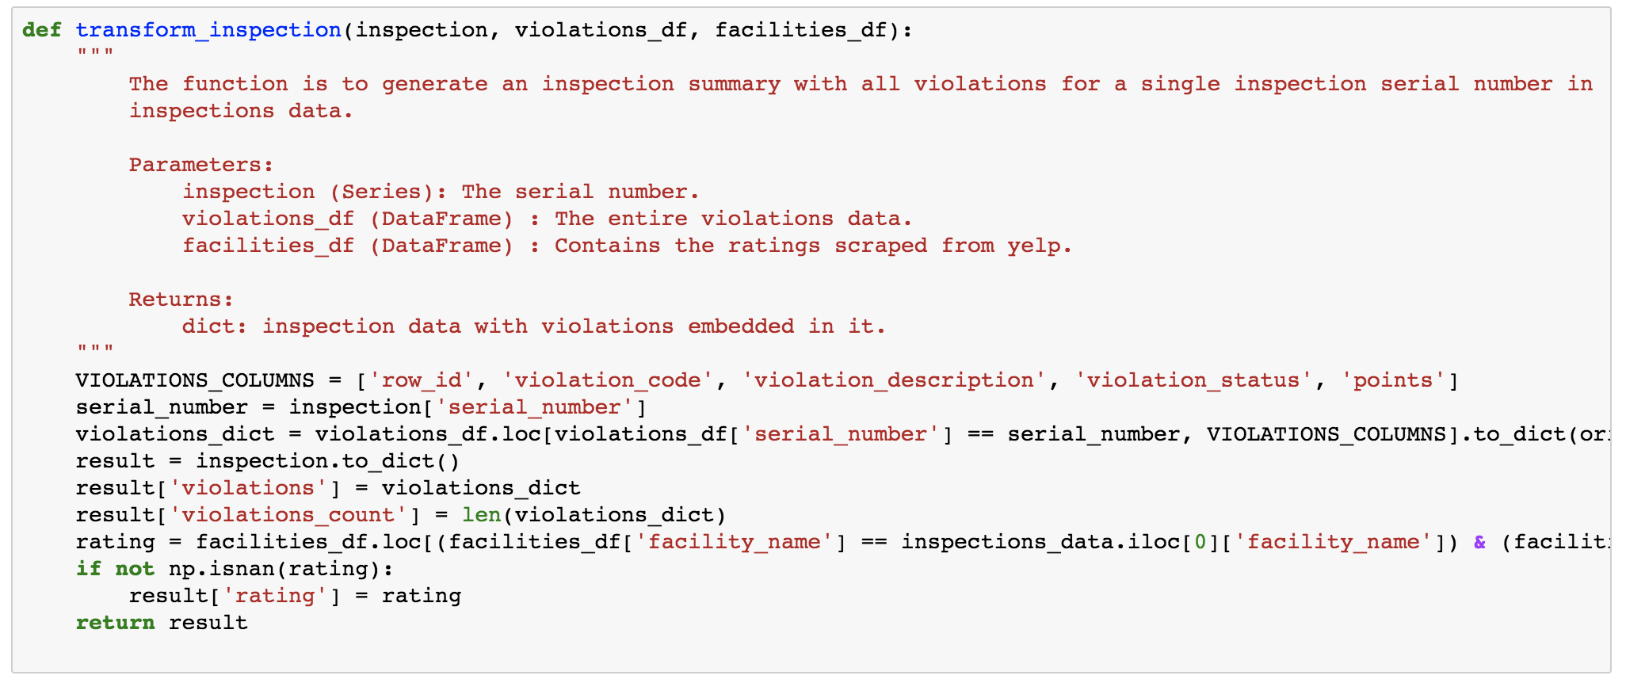

In addition, tried to scrape yelp for ratings for the particular restaurants and incorporated in the inspection summary report.

Finally, we loaded the data into MongoDB.

**Outputs**



